导师简介
姓名 | 刘海强 | 籍贯 | 湖北襄阳 | 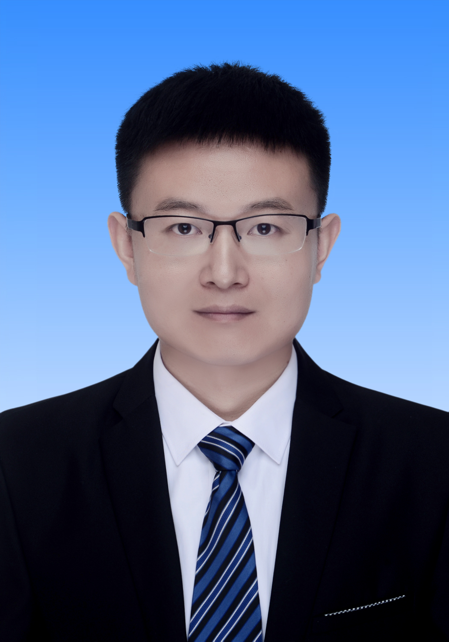
性别 | 男 | 出生年月 | 1989年4月
学历学位 | 博士研究生/博士 | 职称 | 讲师
毕业院校 | 吉林大学 | 指导专业 | 光学工程
研究方向 | 1.新能源材料的合成与性能优化研究；  2.Ag₂Se基柔性热电制冷薄膜的制备与性能优化研究。
教学成果 | 无
主要社会兼职 | 无
个人荣誉 | 黄石市“东楚英才”A类人才
主要代表性成果 | - Haruna, A. Y.; Luo, Y.; Ma, Z.; Li, W.; Liu, H.; Li, X.; Jiang, Q.; Yang, J., High Thermoelectric Performance in Cu-Doped Bi2Te2.7Se0.33 Due to Cl Doping and Multiscale AgBiSe₂. ACS Applied Materials & Interfaces 2023, 15, 49259-49269.  - Haruna, A. Y.; Luo, Y.; Li, W.; Ma, Z.; Yang, L.; Zhang, Z.; Jiang, Q.; Li, X.; Liu, H.; Yang, J., High thermoelectric performance in multiscale Ag₈SnSe₆ included n-type bismuth telluride for cooling application. Materials Today Energy 2023, 35, 101332.  - Liu, H. Q.; Ma, H. A.; Chen, L. X.; Wang, F.; Liu, B. M.; Chen, J. X.; Ji, G. Y.; Zhang, Y. W.; Jia, X. P., Pressure-induced thermoelectric properties of strongly reduced titanium oxides. Crystengcomm 2019, 21, 1042-1047.  - Liu, H. Q.; Ma, H. A.; Wang, C. X.; Wang, F.; Liu, B. M.; Chen, J. X.; Ji, G. Y.; Zhang, Y. W.; Jia, X. P., Enhanced thermoelectric properties of nonstoichiometric TiO_{1.76} with excellent mechanical properties induced by optimizing processing parameters. Ceram. Int. 2018, 44, 19859-19865.  - Liu, H. Q.; Ma, H. A.; Wang, F.; Liu, B. W.; Liu, B. M.; Chen, J. X.; Jia, X. P., Further insights into thermoelectric properties of nonstoichiometric titanium oxide fabricated by high pressure and high temperature. Ceram. Int. 2018, 44, 8043-8047.  - Liu, H. Q.; Ma, H. A.; Su, T. C.; Zhang, Y. W.; Sun, B.; Liu, B. W.; Kong, L. J.; Liu, B. M.; Jia, X. P., High-thermoelectric performance of TiO_{2-x} fabricated under high pressure at high temperatures. Journal of Materiomics 2017, 3, 286-292.  - Liu, H. Q.; Ma, H. A.; Zhang, Y. W.; Sun, B.; Liu, B. W.; Kong, L. J.; Liu, B. M.; Jia, X. P., High-Pressure and High-Temperature Synthesis and Pressure Induced Simultaneous Optimization of the Electrical and Thermal Transport Properties of Nonstoichiometric TiO_{1.80}. Inorg. Chem. 2017, 56, 11275-11281.
联系方式  （电话或邮箱） | hqliu@hbnu.edu.cn

